QFM 2.6 Release Notes
Confidentiality Statement:
The information contained within this document is strictly confidential and contains proprietary and privileged information which is the intellectual property of Service Works Global. It is intended for use by the recipient for evaluation purposes only and may not be reproduced or disclosed under any circumstances without the express written permission of an authorised authority of Service Works Global.in confidence.
What’s New in QFM v2.06.00.02

March 2020

Contents
Contents 1
Version Log 2
Release Notices 3
QFM Compatibility 3
New Features Summary 4
New Features 5
Event Audits Module 5
Overview 5
Bulk Link Assets to Events 7
Overview 7
Introduction 8
Dynamic Forms - Dependencies Between Controls 11
Overview 11
Introduction 11
Validation Rule Controls 12
Dynamic Forms - Filtered Lookup List Controls 16
Overview 16
Introduction 16
Lookup Lists 17
Creating Lookup Lists 18
Creating Filtered Lookup Lists 21
GPS Tracking of Visits and Events 23
Overview 23
Introduction 23
Timestamp Audit Entries 24
Overview 24
Introduction 24
Known Issues 25
Administration 25
Dynamic Forms 25
Miscellaneous 25
QFM Installation Notices 26

Version Log

Version # | Summary of Revision | Date | Author
1.0 | First edition v2.06.00.02 | 13/03/2020 | MR

Release Notices

QFM Compatibility
The QFM 2.06.00.02 release is compatible with the following QFM software:

- QFM App v1.17 (Compatible with QFM version 1.36 and above, QFM Mobile Server version 2.02 and above. Use QFM 2.06.00.02 and QFM Mobile Server 2.08.00.05 to gain access to latest features).
- QFM Workflow Scheduler v2.06.00.02.
- QFM Mobile Server v2.08.00.05.
- QFM Desktop v164.08.11.01.

In order for this release to perform at an optimum level, Service Works strongly recommends that client organisations upgrade to these software versions or later.

New Features Summary
The QFM v2.06.00.02 release includes a range of new features. A summary is provided below, with further details on the following page.

Event Audits Module
The QFM Event Audits module provides facilities managers with the ability to monitor the quality and effectiveness of work previously carried out, through a series of inspection audits. The module allows survey specifications to be set up, scheduled and carried out via physical location visits; with the results consolidated for easy assimilation and analysis.

Bulk Link Assets to Events
The facility which allows Assets to be linked to Events, is now enhanced to include two additional sources; Assets form List Reports and Assets from Asset Groups. When selected, these options allow Assets to be linked to Events in bulk.

Dynamic Forms - Dependencies Between Controls
Dynamic Form Validation Rules are enhanced to allow a greater range of options for designing the flow of question sets, used for carrying out surveys in the field. This allows the design of specific pathways through a form, dependent on the answers given for particular survey questions.

Dynamic Forms - Filtered Lookup List Controls
Dynamic Forms can now be designed so that questions which utilise lookup selection lists can have the list of options filtered specifically from a response given to a previous (linked) question.

GPS Tracking of Visits and Events
The GPS location of a mobile device running the QFM app is now recorded in the QFM Visit Log. Coordinates are recorded for key transactions and the data is available for custom reports.

Timestamp Audit Entries
The QFM app allows users to change Visit Started and Completed dates and times from the values which are automatically recorded. The system now retains the actual Visit Started and Completed dates and times, with timestamps for these stages recorded in the QFM Visit Log.

New Features
Details of QFM v2.06.00.02 enhancements are provided in this section.

Event Audits Module

Overview
Quality monitoring is an important part of many facilities management contracts. The QFM Event Audits module provides facilities managers with the ability to monitor the quality and effectiveness of work previously carried out, through a series of inspection audits. The module allows survey specifications to be set up, scheduled and carried out via physical location visits; with the results consolidated for easy assimilation and analysis.
A Survey Definition and Schedule are used to generate Inspection Tours during a defined Audit Period. Once an Inspection Tour is generated, it allows individual Inspection Visits to be conducted by auditors using a mobile device running the QFM app. The auditor receives the Inspection Visits on their device together with key information for the work to be inspected. Following this, the work is deemed to either ‘pass’ or ‘fail’ the inspection, according to the criteria set.
QFM Event Audits leverages the existing Dynamic Forms functionality, making it highly configurable. As a result, the QFM mobile app can be set up to prompt the auditor for additional information. It also supports the auditor in attaching photographs as evidence of inspection results.
Audit results can be rolled up into management reporting and dashboards, delivering significant business value and giving facilities managers statistical evidence of service and performance trends. It can highlight any inconsistencies or fundamental changes in performance over past periods, signalling that investigation or corrective management action is required.

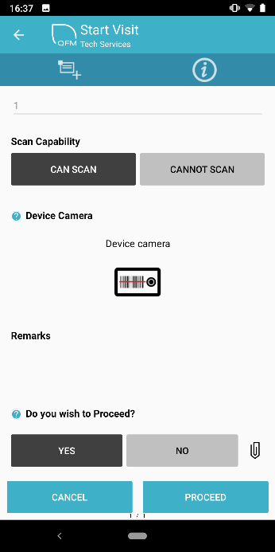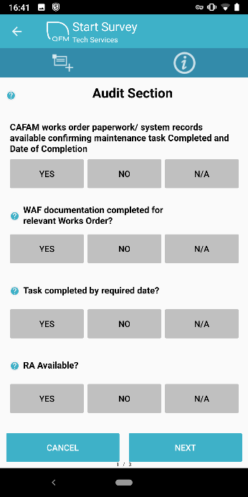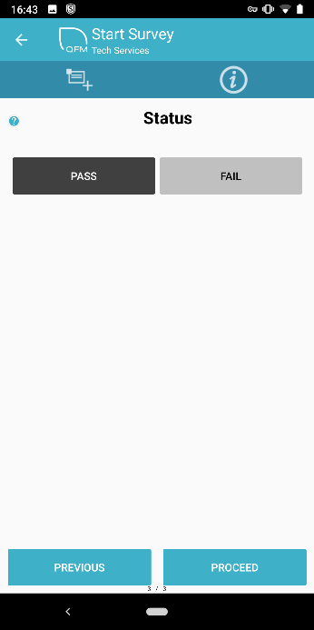

Features and benefits include:
- Schedulable inspection tours carried out using QFM mobile application
- Tour inspections of work carried out selected on a randomised basis
- Define audit question sets and templates
- Clean, clear user interface for use ‘in the field’ by auditors
- Ability to raise Remedial Events from mobile application
- Link quality monitoring results into PFI/P3 payment mechanism performance calculations
- Provide management with dashboards for monitoring of performance quality
- Increase visibility of non-compliance so managers can proactively improve performance
- Ensure complete transparency of inspection audits between service provider and customer

Refer to the separate QFM Event Audit Guide for full details of Event Inspection processing.

Bulk Link Assets to Events

Overview
Improvements have been made to help users bulk link Assets to an Event much more effectively. Support has been added to be able to use pre-saved Queries and saved Asset Groupings to provide the Assets which are to be linked, rather than forcing the user to go and find and link each Asset serparately.

An example of the benefit this can provide would be where an Asset Grouping is defined to contain Fire Extinguishers that require inspection. With this development, users can simply refer to the required Asset Grouping and select one/more/all of the returned results to link to the current Event. Using
pre-saved Queries gives users considerable flexibility to define a sub-set of Assets they may wish to quickly bulk link.

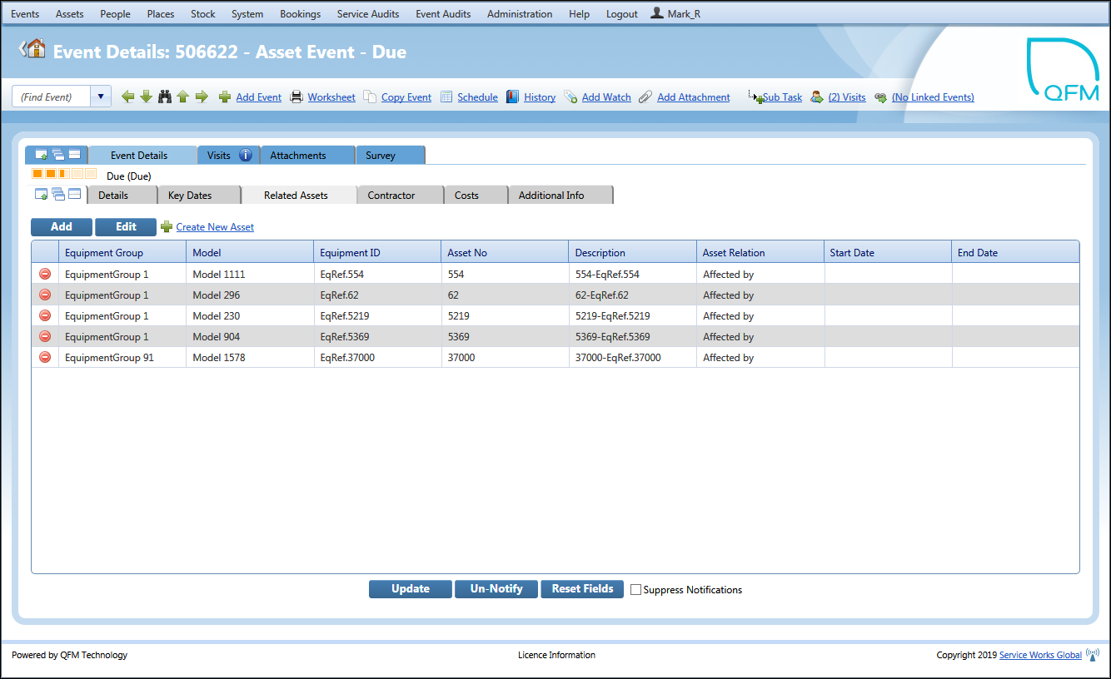

Benefits include:
- Greater efficiency to the process of linking Assets to Events, by utilising bulk processing rather than having to find and link Assets one by one.
- More choice over the types of Asset which can be linked to Events.
- This method offers more flexiblity than the traditional ‘Primary/Subsiduary Asset’ method traditionally used (where raising a job against a Primary Asset will result in Subsiduary Assets being automatically referenced in the Visit on the QFM app) as it is possible to have multiple groupings, not just a fixed association with a single set of child Assets.

Introduction
The facility which allows you to link Assets to an Event, where a relationship exists, is now enhanced.
The Add Related Asset screen (available via the ‘Event’ screen, ‘Related Assets’ tab) now allows two additional methods for linking Assets to Events. These enable Assets to be linked in bulk from List Reports and Asset Groups.

From List
This option allows you to add the Assets associated with a List Report, to an Event.

Check the From List option to select Assets included in List Reports.

Note: Only Asset List Reports are available to select.

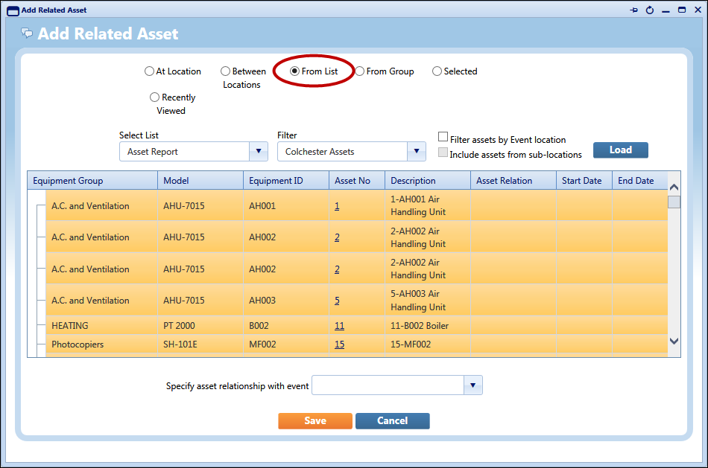

Select an Asset List Report from the Select List drop-down list. You can also specify any Filters applied to the report.

The Filter assets by Event location filter enables you to select only those assets at the geographic location of the Event.

The Include assets from sub-locations filter enables you to select assets at the geographic sub-levels below the location of the Event. (This control is only enabled if ‘Filter assets by Event location’ is selected).

Select Load to display the Assets.

From Group
This option allows you to add the Assets associated with an Asset Group, to an Event.

Check the From Group option to select Assets included in Asset Groups.

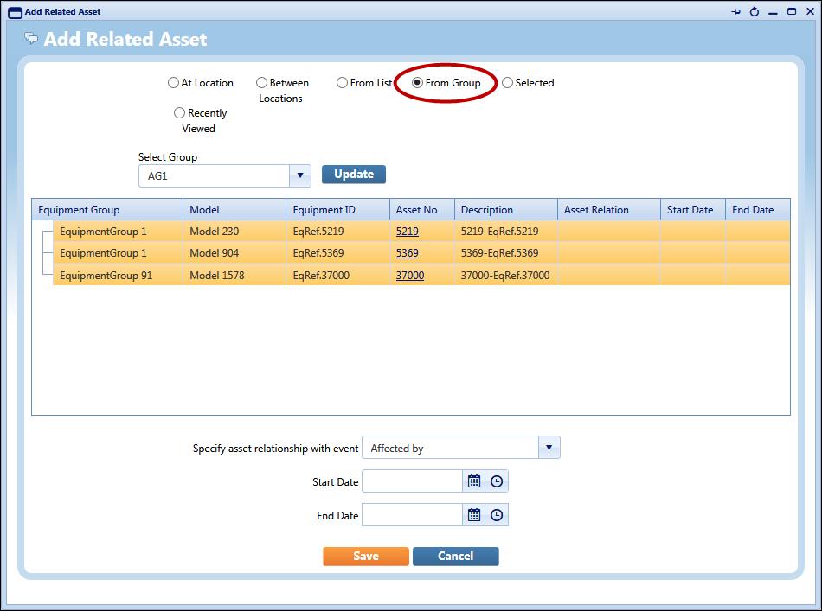

Select an Asset Group from the Select Group drop-down list. Select Update to add the Asset Group.

Dynamic Forms - Dependencies Between Controls

Overview
Dynamic Form Validation Rules are now enhanced to allow a greater range of options for designing the flow of question sets, used for carrying out surveys in the field. This allows you to design specific pathways through the form, dependent on the answers given for particular survey questions.

So, for example, you can specify a condition that says;
If the answer to question 4 is ‘X’, hide question 5 and continue from question 6. (Therefore, if the answer is anything other than ‘X’, question 5 is presented).

It is possible to hide and show whole sections based on the state of another control.

Using these new controls, you can build forms which can efficiently cover a range of different scenarios. This feature is only available for Dynamic Forms used on the QFM mobile app.

Benefits include:
- Saves time by making forms more efficient to complete, i.e skipping those questions which are not relevant.
- Forms can be made more interactive with the addition of specific routes for the user, dependent on the responses they provide.

Introduction
Dynamic Form Validation Rules can be specified for particular Panel Controls. Previously, this enabled you to define the type of response required when a survey was being completed, or whether a response was mandatory. You could add a Warning Level which determined the level of enforcement when a validation failed. You could also add a Message to be displayed if the validation was breached when the form was being completed.

You can now specify an Action instead of a Warning Message, which can change the properties of other controls (questions) on the form to be either visible or hidden (or enabled/disabled) based on the Validation outcome. This allows you to design specific pathways through the form, dependent on particular answers.

For example, Control 4 on a form may be “Is any remedial work required?”
You can create a Validation which only enables Control 5 “Describe the remedial work required” to be visible if the answer to Control 4 is “Yes”. If the answer given is “No” then the operative carrying out the survey will only see, and continue from, Control 6, the next question.

This feature applies to Section level controls as well as individual controls so it is possible to hide or show a whole section based on the value selected.

Note: There are some limitations with the current implementation. As a result, these features:
- Cannot be used for Web Based Forms.
- If using dependant actions to ‘hide/show’ and/or ’enable/disable’ controls, then Form Scoring should not be used.

Validation Rule Controls
Validation Rule controls are available in the Dynamic Forms screen (Administration > Dynamic Forms).

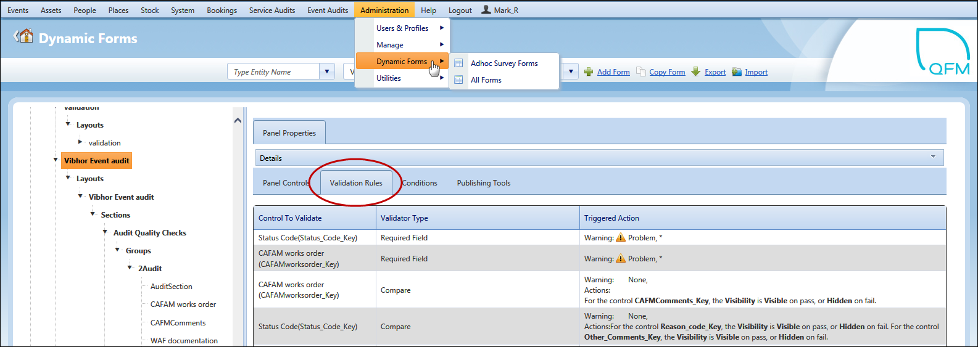

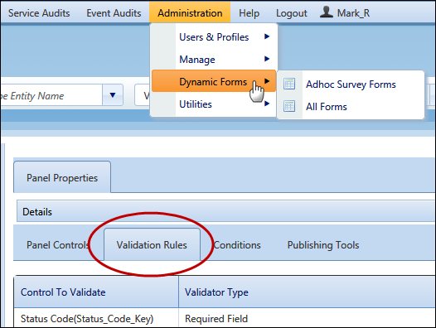

The Validation Rules grid has the following columns:

- Control to Validate (giving the name of the control against which the validation is made - as currently implemented).
- Validator Type (giving the type of validation that is made - as currently implemented).
- Triggered Action (giving a textual description of the Validation or Action - this replaces the existing columns of "Validation Message" and "Warning Level").

To add Validation Rules:

- In the Validation Rules tab, select Change.
- Select .
- In the Control To Validate field select the control against which the validation is to be made, from the drop down list.
- In the Validator Type field select the type of validation from the drop down list.
You can change the default properties for each Validator via the icon (as shown in the example below).
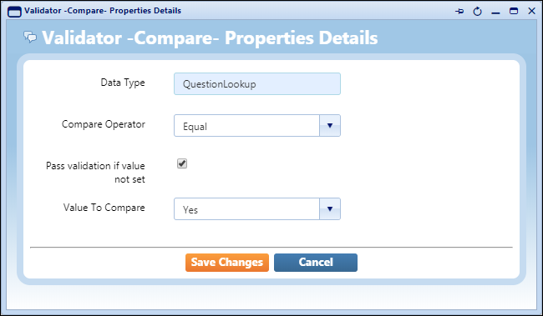
- In the Triggered Action field select the icon.
There are two parts to the Action Specifications window.
The top section allows you to specify a Warning Level and a Warning Message displayed if the Validation check fails.
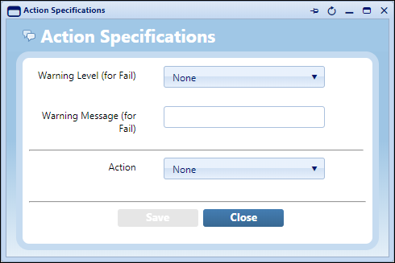
In the lower section select Set Control Property in the Action field, to enable a set of field controls below.
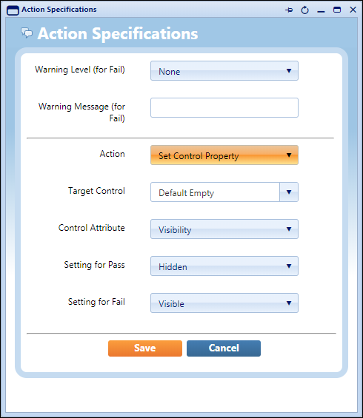
In the Target Control field select the Control which is the target of the action.
In the Control Attribute field select Visibility or Edit Ability.
Visibility allows you to hide or show the control in the event of a pass/fail, via the fields below.
Edit Ability allows you to make the control read-only or editable in the event of a pass/fail, via the fields below.
In the Setting for Pass field select either Hidden / Visible or Read-only / Editable, as above.
In the Setting for Fail field select either Hidden / Visible or Read-only / Editable, as above.
Select Save then Close.
- Select then Save Changes.

Dynamic Forms - Filtered Lookup List Controls

Overview
QFM Dynamic Forms can now be designed so that form questions with selection list values are filtered specifically by a response given to a previous (linked) question.

For example, question 4 on a survey form asks the user to confirm which building Floor they are on; the user selects “Ground Floor” from the Lookup List. Question 5 asks the user to select the Room they are inspecting. Only Rooms on the Ground Floor are shown in the Lookup List, as the filter configuration links Control 5 with the response given to Control 4.

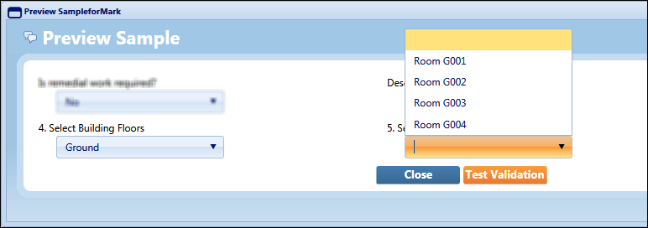

Benefits include:
- Lookup list options become more precise, making it easier to select the values required.
- Lookup lists will in most cases become smaller, again making them easier to use.
- Helps to reduce the margin for error when selecting from a Lookup list.

Introduction
QFM Dynamic Forms now allows you to design form questions with selection list values which are filtered and specific to a response given to a previous (linked) question.

This feature is available for controls with a Control Type of Lookup Question. You can configure the form question to show the user a lookup list containing only values which are relevant to an answer they have given against a previous form question. This can make lookup lists much more specific and dramatically reduce their size, making it easier to select the values required.

The set up of this feature requires at least two Lookup Lists to be created in a hierarchical manner. The higher level list should be at ‘Group’ level and the Lookup items on the lower level list should be linked to an item at ‘Group’ level. This creates a relationship so that when the user selects a Lookup List item at ‘Group’ level, from a form question A; when they open the Lookup List in form question B, they only see the Lookup Items which have a link to the ‘Group’ level item (selected in question A).

Example:
A user is completing a survey form. Question 4 asks the user to confirm which building Floor they are on; the user selects “Second Floor” from the Lookup List. Question 5 asks the user to select the Room they are inspecting. Only Rooms on the Second Floor are shown in the Lookup List, as the filter configuration links Control 5 with the response given to Control 4.

Lookup Lists
Before you can create filter links between controls, you must create the Lookup Lists to be filtered. These are created in the Dynamic Forms system and are not allocated to individual Controls at this stage.
Using the example illustrated above, you would first add a Lookup List (Lookup Type) of “Building Floors” with Lookup Items of “Ground”, “First”, “Second” etc., (as shown in the example below).

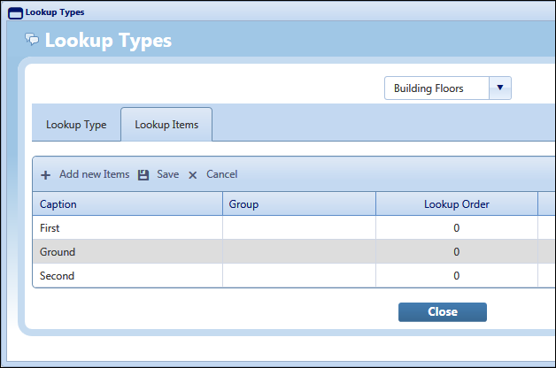

You would then add another Lookup Type of “Building Rooms” with Lookup Items for each Room in the building. Each Room is also assigned to a “Group”, which in this example is one of the Floors; “Ground”, “First”, “Second” etc., (as shown in the example below).

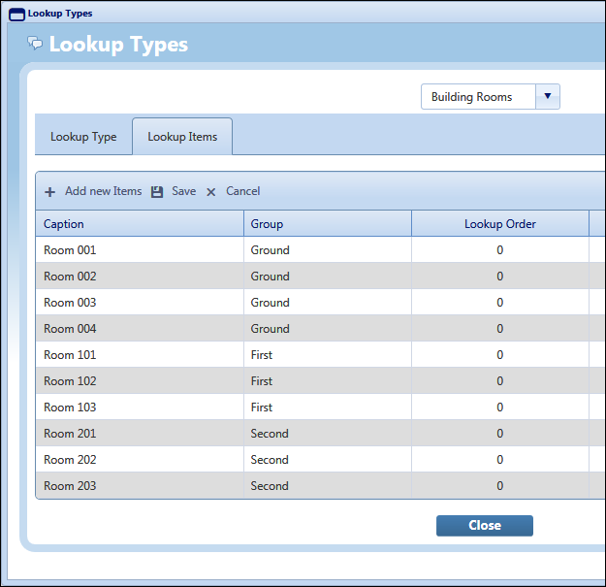

By linking each Room to a Floor, the form is able to present a filtered list of Rooms according to the Floor specified previously.

Creating Lookup Lists
To create new Lookup Lists, follow the steps below.

Note: You will be either creating new Panel Controls or editing existing Controls.

- In the Dynamic Forms screen, Panel Controls tab, ensure that Lookup Question is selected in the Control Type field.
- Open the drop down list in the Lookup Type field. Select the icon to add new Lookup Types, (as shown in the example below).
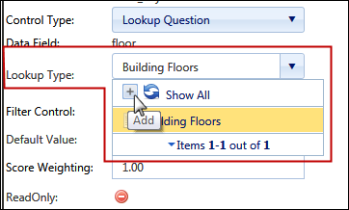
- In the Lookup Type tab select .
This first Lookup List will be the top level in the hierarchy.
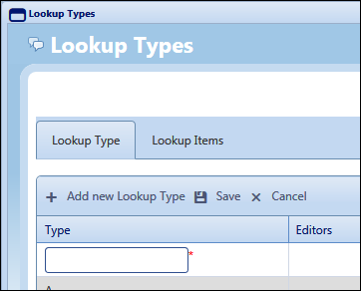
- Enter the new Lookup Type name in the Type field.
Select .
- Go to the Lookup Items tab.
Select the Lookup Type name from the lookup list at the top of the screen 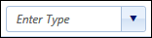
- Select .
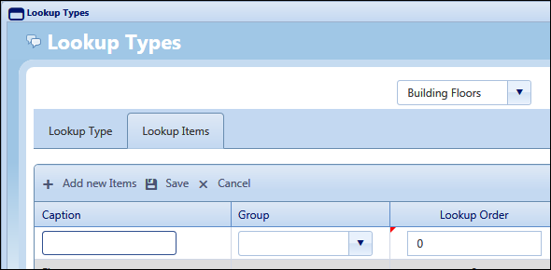
- Add each item for the Lookup List; once you have added one item, select to add the next, etc. Once all items are added, select then Close.
Note: To create the environment for Filtered Lookup Lists, your first (top level) list will not need to have Group values assigned to the items, as the items in this list will become the Groups for the lower level Lookup Lists.
- Continue from Step 3 to add your next Lookup List. If this is at a lower level in the hierarchy, e.g. this is a list of Rooms and the previous (higher level) list was building Floors, then each item must be assigned to a ‘Group’.
For example, each Room would be assigned to a ‘Group’ which would be the building Floor. In this scenario the Lookup Items could be as follows:
- Continue until you have added all the Lookup Types and Lookup Items required.

Creating Filtered Lookup Lists
Once you have created a set of hierarchical Lookup Lists, you can configure the Panel Controls to make the filter link between Lookup Lists.

Note: You will be either creating new Panel Controls or editing existing Controls.
The Panel Control to be updated is the lower level Lookup List, as it references the higher level Lookup List acting as the ‘Group’.

- In the Dynamic Forms screen, Panel Controls tab, ensure that Lookup Question is selected in the Control Type field.
Select the Lookup List to be used in the form question, in the Lookup Type field.
- In the Filter Controls field, select the Lookup List on which you wish this list to be filtered by.
For example, if the Lookup List in this Control is a list of Rooms, then you would enter the name of the Floors Lookup List. This would ensure that only the list of Rooms which are Grouped to the Floor selected by the user in a previous question, will be displayed.
Refer to the example below.
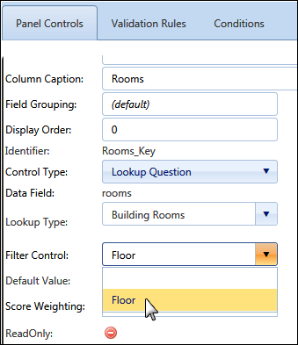
- Save the Panel Controls.

You can test the Controls to check that the Lookup List Filtering is correctly configured, by selecting

The example below shows two Controls; ‘Floors’ and ‘Rooms’.

The ‘Floors’ Control includes a higher level Lookup List of building Floors.

The ‘Rooms’ Control includes a lower level Lookup List of Rooms, which references the ‘Floors’ list upon which to filter.

In this example, the ‘Ground’ floor has been selected on the ‘Select Building Floors’ question.
This means that only those Rooms on the Ground Floor will be present in the Lookup List on the ‘Select Building Rooms’ question.

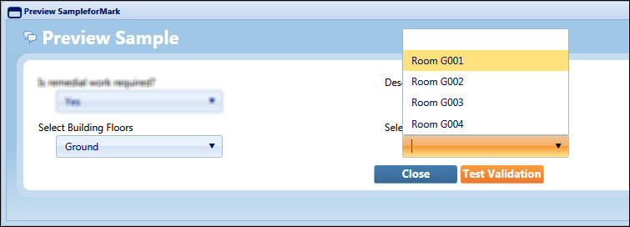

GPS Tracking of Visits and Events

Overview
The GPS location of a mobile device running the QFM app is now recorded in the QFM Visit Log.
Coordinates are recorded for key transactions and the data is available for custom reports.
Please refer to Service Works for further details.

Benefits include:
- Greater ability to audit mobile operative activities.

Introduction
QFM now records the GPS location coordinates of a mobile device running the QFM app. Data is recorded for key transactions and saved in the QFM Visit Log.

This information is intended for future use, however it can be provided in custom reporting.

Please refer to Service Works for further details.

Timestamp Audit Entries

Overview
The QFM mobile app allows users to change Visit Started and Completed dates and times from the values which are automatically recorded. The system now retains the actual Visit Started and Completed dates and times, with timestamps for these stages recorded in the QFM Visit Log.

Benefits include:
- Administrators now have the ability to identify the actual Started and Completed dates and times for Visits, regardless of whether these details have been changed by the user.

Introduction
The QFM mobile app allows users to manually change Visit Started and Completed dates and times from the values which are automatically recorded. The system now retains the actual Visit Started and Completed dates and times, with timestamps for these stages recorded in the QFM Visit Log.

The timestamps are identified as:

- VisitStartedTS - set to UtcNow when the Visit is Started.
- VisitCompletedTS - set to UtcNow when the Visit Completed is page is finalised.

This data is available for custom reports.

Known Issues
This section details new system issues which remain open in v2.06.00.02. These will be rectified at the earliest opportunity.

Administration

Dynamic Forms
23849 | Issues exist with the Dynamic Forms Compare validator.  Whilst a user may define multiple 'Validator Actions' which affect the same 'Target' controls, this is not a supported configuration and may lead to ambiguous behavior for the end user. It is strongly suggested that the Compare Validator is avoided as there is no guarantee that the behaviour will be consistent or will not be disturbed by future upgrades.

23643 | Dynamic Form Reporting (including Surveys) does not respect the enhancements made to the dependent controls either with layout or scoring. Sections and all controls are always included in reports (even if hidden during data entry). If these new features are used, reports should not include any scoring information as this may be misleading for some scenarios where scorable controls are hidden.

23136 | The scoring from Dynamic Forms represented within the corresponding Web List does not take into account the effects of hiding sections and controls on the QFM mobile app. This functionality is currently incompatible. If clients are making use of the scoring data from a QFM List Report then it is not possible make use of the extended features on the QFM app which have an impact on scoring.

Miscellaneous
10485 | Issues may occur if installing the Service Works Group - QFM Outlook Plugin.  If the Plugin is a different version to an existing version already installed, this may result in the loss of some controls from the ribbon bar, i.e. the Configuration and About controls.

QFM Installation Notices
This release is compatible with QFM Desktop 164 versions only.

Service Works Global (SWG) does not recommend QFM is run with Internet Explorer 6, 7 or 8 browsers. Use of these lower specification browsers may result in users experiencing unstable operation, script, rendering and performance issues. SWG has no current plan to address these issues.

The Workflow Scheduler is a mandatory requirement in order to run this QFM release, as it performs essential background tasks.

SWG is not responsible for user defined reports and should a client upgrade from a non-time zone database to a time zone enabled database it is likely that their user defined reports will be affected as all times and dates will be relative to UTC not local time.

SWG strongly recommends clients review all reports against an upgraded database before relying on the output.

It is the responsibility of the client to ensure any issues are addressed, however Service Works Global may provide consultancy at the standard rates specified in the Customer Order to help the process should this be required by a client.

Please contact your SWG account manager if you need to make use of this service.

QFM includes SAP Crystal Reports runtime environment to enable users to benefit from integrated web based reporting. Clients should refer to the SAP website (www.sap.com) to understand the full strengths and capabilities of the product. SWG will make best endeavours to help support and resolve any issues that arise in this environment but as it is a third party product SWG does not provide any warranties over its abilities or functionality. SWG will aim to implement new patches to this software as they become available and are viewed as stable. It is the client’s responsibility to ensure that any bespoke user reports work within the environment provided. Furthermore, extensive concurrent use of reporting within QFM can negatively impact the performance experienced by interactive users. This should be monitored and controlled accordingly.

QFM utilises some 3rd party components, as listed below, in order to provide extended functionality. Use of these products may be subject to separate license agreements with the specific vendors/service providers. Use of these 3rd party components is not covered under the QFM licensing agreement with SWG. It is the client’s responsibility to ensure that they have up to date licensing for these specific 3rd party products before they are used within the QFM product.

Crystal Reports (http://www.sap.com/uk/solutions/sap-crystal-solutions/query-reporting-analysis/sapcrystalreports/licensing/index.epx)

Google maps (https://developers.google.com/maps/licensing) (a business license may apply)

QFM is designed to be run on a range of devices such as tablets and smartphones. These devices may have little or no native support for certain features such as printing, Skype, Facetime, Telephony, etc. QFM does not limit the use of these features but their use is not supported under the standard QFM license agreement.

Please note that support for some Self Service user profile settings has changed. A default value of zero is no longer supported for the following administration settings applied to the Self Service user profile:
● Priority
● Worktype
● Service
● Service Group

Users with a Self Service profile will no longer be able to save events if their default values have not been updated. Client organisations upgrading to version 1.29 onwards should check these Self Service default settings to ensure they have a value other than ‘0’, as ‘0’ is no longer supported.

Users who use Self Service express event logging should validate that the process is unaffected. If any issues are encountered, users simply need to check the aforementioned settings and replace any values of ‘0’.

